**Informative Social Media Content Identification**

**Table of contents**

1. ABSTRACT………………………………………………………………3

CHAPTER 1 ….. 4

1. Introduction….….………………………………………………………………………………………4
   1. Types of Social Networking Sites………………………………………………………………….5
   2. Twitter Platform……………………………………………………………………………………5
   3. Background of the Study ….………………………………………………………………………7
   4. Objectives …....……………………………………………………………………………………..7
   5. Research Questions …..……………………………………………………………………………8
   6. Ethical Considerations ….…………………………………………………………………………8
   7. Project Timeline …...……………………………………………………………………………….8

CHAPTER 2 .. ………………………………………………………………………………………...10

1. Literature Review .………………………………………………………………………………………10

CHAPTER 3  28

1. Project Design and Methodology ...……………………………………………………………………28

CHAPTER 4  31

1. Results and Discussion………….…………………………………………………………………..…31

CHAPTER 5  36

1. Conclusion …………...………….…………………………………………………………………..…36

REFERENCES  37

# **Abstract**

Social Media has found a way into each aspect of human life over the past decade. This makes social media a very significant part of life. Social media is also replacing news sources as it is more effective in spreading and delivering news throughout the world. Since social media is so popular, people have been referring more social media for updates on what’s going around in the world. Social networking sites have revolutionized traditional information-sharing methods. They are mostly built on an individual’s offline social circle and they provide users with a wide variety of virtual interaction mechanisms. Such sites and applications have become important communication platforms that are integrated into the daily life of many users.

However, they have also blurred the line between users’ offline and online lives and created the illusion of familiarity and intimacy over the web, which may have resulted in the sharing of a significant amount of personal information that users might have preferred to remain private. The technology of social networks is a double-edged sword. Due to freedom of usage in social media, it generates a lot of data sifting through which is hard work. People that look for information of some kind on social media can’t find it because it’s lost under all that data. It is like finding a needle in a haystack. Social media has changed how people not only communicate but also how convey the information to their target audience. There are four critical social media outlets currently dominating the market: Facebook, Twitter, Pinterest, and Instagram. While Facebook and Twitter have been mainstays for quite some time now.

This research is focused on dealing with this issue by automating the process of finding informative content on social media. The purpose of this research to identify the informative social media content identification from twitter enabled with machine learning in the form of Naïve Bayes Theorem.

**Keywords:** Machine Learning, social media, Twitter, Naïve Bayes Theorem, Informative Content.

**CHAPTER 1**

1. **Introduction**

Person to person communication locales have altered customary data sharing strategies. They are for the most part based on a person's disconnected group of friends and they give clients a wide assortment of virtual cooperation instruments. Such destinations and applications have become significant correspondence stages that are coordinated into the everyday life of numerous clients. Nonetheless, they have additionally obscured the line between clients' disconnected and online lives and made the dream of commonality and closeness over the web, which may have brought about the sharing of a lot of individual data that clients may have liked to stay private. The innovation of informal communities is a blade that cuts both ways. Despite the fact that it can give incredible advantages to its clients, it accompanies a tremendous cost and duty: clients' security. It clients are not simply the wellspring of data; they are additionally the objectives. They leave advanced impressions during their visits to those sites and versatile applications, where security penetrates and wholesale fraud cases are expanding at a disturbing rate. Clients are helpless against protection breaks from a wide range of substances. They can emerge out of its specialist organizations, outsider applications, different clients from its clients' informal communities, or other pernicious assailants. Be that as it may, security assurance obligation lies essentially with the individual client and frequently relies upon clients' degrees of individual data exposure and information on insurance techniques. The sharing of individual and recognizing subtleties like sex, age, training, area, address and other individual data, for example, individual and family photos can help with building up a character that can be handily taken and utilized by hoodlums. Fraud crooks abuse the absence of attention to its clients to accumulate individual data that has been unreservedly provided by the client.

The rise of interpersonal interaction destinations in individuals' day by day lives has changed the manner in which clients convey and share data. Prior to SNSs, individuals' methods for correspondence and data sharing were extremely restricted, particularly as far as association, and individuals for the most part spoke with others they knew by and by. Right now, people use SNSs to share client produced content online through PCs or cell phones in a wide range of configurations, contingent upon the interpersonal organization of their decision (Ge, Peng, and Chen, 2014). Clients share news about their lives easily, regardless of whether it is as a video, a photograph, a post or an announcement. What's more, clients these days share data with a lot bigger crowd, once in a while bigger than they plan.

Advances in innovation have empowered SNSs to foster tremendously in a manner that has made new techniques for sharing data. Interpersonal organizations started as sites where clients just approached by means of a PC or work area. Notwithstanding, with the improvement of cell phones, informal communities delivered versatile application variants and additionally created independent portable applications. This advancement made it simpler and more helpful for clients to get to their online profiles, refreshing them all the more effectively and continuously (Aldhafferi, Watson, and Sajeev, 2013). Nonetheless, the more open the interpersonal organization and the simpler it is to utilize, the more data clients share (Coyle and Vaughn, 2008) because of its steady presence in their lives. SNSs certainly have a solid social effect; notwithstanding, accordingly, the lines between people's virtual and disconnected lives have been obscured.

As of August 2016, there were over 2.34 billion informal organization clients universally. This number is relied upon to increment to 2.95 billion informal organizations clients by 2020, which is roughly 33% of the world's whole populace (Statista, 2016). Because of the expanded utilization of SNSs, interpersonal organizations have become rich wellsprings of clients' very own data. Clients' own data is truly significant to various gatherings and can be abused for monetary benefit. First and foremost, sponsors can attack clients' security by getting to their own data and perusing propensities, which is provided by SNS suppliers, to suggest items and administrations; such advancements are alluded to as focused customized promotions. Furthermore, sharing of individual data like complete name, age, sex, and other individual data, for example, family photographs leaves clients powerless against online crooks, who may endeavor such data for pernicious activities like fraud or internet following. Such activities can influence clients' security and cause monetary misfortune as well as passionate misery to the people in question.

Social media has changed how people not only communicate but also how convey the information to their target audience. There are four critical social media outlets currently dominating the market: Facebook, Twitter, Pinterest, and Instagram. While Facebook and Twitter have been mainstays for quite some time now.

* 1. **TYPES OF SOCIAL NETWORKING SITES**

SNSs can be separated dependent on their motivation and functionalities. For instance, Twitter is a fitting site if the client is looking to send a short message to an enormous crowd, yet it is unrealistic for attempting to speak with different clients if the message is bigger than 140 characters. Also, if a client wishes to post a video message rather than text, the most proper instrument is YouTube. The focal point of this examination is on four SNSs: Facebook, Twitter, Instagram, and Snapchat. Every one of these SNSs has an alternate reason, various functionalities, and gives the client various encounters. Hence, this segment will depict the idea driving each SNSs and what sort of close to home data it contains and shows. The accompanying data was recovered from every SNS in May 2016.

* 1. **Twitter Platform**

Twitter permits the client to post "tweets", which are messages that can't surpass 140 characters. The client profile is public of course however the client can restrict their profile and make it private. Twitter clients can add the data appeared in Table 1.1 to their profiles and this data is public regardless of whether the client's tweets are private:

Table 1.1 User Profile options and default privacy settings in Twitter

|  |  |
| --- | --- |
| **Feature** | **Default Privacy setting** |
| Username and profile name | Public |
| Photo (profile and background) | Public |
| Bio (the user can type any brief information about themselves) | Public |
| Location (which country or city the user lives in) | Public |
| Website (if the user has one) | Public |

The default is continually disclosing data and collectable by Twitter. Twitter tracks what different sites the client has as of late visited. Twitter utilizes the gathered data to give custom fitted advertisements and ideas to the client by offering it to Twitter's promotion accomplices, which is consented to as a matter of course when clients join to Twitter. In any case, following a limit of 10 days, Twitter guarantees that it eliminates all record identifiers from the information that was gathered from site pages the client visited. To give clients more protection, Twitter upholds a no-following security inclination, which can be set in internet browsers and on Twitter accounts. Try not to Track (DNT) empowers clients to control how their data is utilized by Twitter to customize their experience. Notwithstanding, in light of the fact that the following is naturally done, clients need to visit their record and program settings and handicap these capacities by unchecking the crates. Also, Twitter gets data about the client from promotion accomplices and matches it with the client's Twitter account. In light of this data, the client will get promotions. Twitter can get email records from organizations and might be approached to advance items or administrations on Twitter by coordinating with the email records to Twitter accounts. Then again, the business can impart to Twitter data about the clients who visit the business site so that Twitter can coordinate with their record and these clients get the advertisement. Clients need to uncheck the naturally checked catches on the off chance that they don't want their record to be coordinated with data gave about them by Twitter's promotion accomplices.

At the point when a client decides to deactivate his/her record, Twitter will in any case claim the rights to the client's substance, with the exception of the copyright permit, which endures end. Following 30 days, Twitter begins the way toward erasing the client's record. Nonetheless, even subsequent to deactivating the client account or erasing, the client's public tweets won't vanish from web search tools and other outsiders.

Besides, Twitter can alter its terms and conditions strategy any time it sees fit. It will tell the client, by means of their authority twitter account or through email. In September 2009, Twitter gave short notification before it considerably adjusted the terms and conditions strategy for the copyright permit, only a couple hours before it applied the progressions to its arrangement (Tosdr, 2012). Regardless of whether the clients didn't browse their email or their Twitter account, on the off chance that they kept on getting to Twitter after the progressions to the strategy they were as yet limited by the updated strategy.

In its security strategy, Twitter shows that clients ought to painstakingly consider the public substance that they post in light of the fact that when a client posts something in their open profile, the data is promptly shipped off Twitter's accomplices and outsiders by means of SMS and APIs. This incorporates designers, web indexes and distributers, with the goal for them to coordinate Twitter content into their administrations. Also, Twitter's data sharing incorporates associations like colleges and general wellbeing foundations, which utilize and examine the data to create patterns and experiences. The utilization of "quickly" in its security strategy demonstrates that all the data is moved consequently, which may likewise show that regardless of whether the client erases the data they posted after some brief period, the data will in any case be there with Twitter's accomplices. There is no sign by Twitter whether the data imparted to their outsider accomplices is anonymized.

This examination is centered on managing this issue via mechanizing the way toward discovering educational substance via online media. The motivation behind this examination to distinguish the instructive web-based media content recognizable proof from twitter empowered with AI as Guileless Bayes Hypothesis.

**1.3 Background of the study**

The rapid increase in the popularity has shown results far beyond anything expected. The sheer amount of data produced by social media alone is nothing to scoff at. The information sharing ability of social media is unmatched, making anything minutely attractive viral within a matter of minutes. This amount of data and prowess must be properly utilized.

The flourishing of microblog stages, for example Twitter, brings the enormous scope, boisterous also, client created short posts. An occasion via online media is a progression of microblog posts about a hot hashtag. Consequently, separating subjects of an occasion on friendly media expects to uncover the topical data of the posts. It is important to the downstream applications, for example, outline (Zhang and He, 2018), hashtag suggestion (Zhang and He, 2018), reaction age (Zhang and He, 2018), etc. The traditional theme models, as Latent Dirichlet Allocation (LDA) (Zhang and He, 2018), induce the secret points dependent on the word co-event in a long archive. Notwithstanding, they couldn't be straightforwardly applied in online media because of the information sparsity and the commotion of short messages (Zhang and He, 2018). To manage the issue, most examinations total presents on a long pseudo document as indicated by initiation (Zhang and He, 2018) or hashtags (Zhang and He, 2018).

The requirement of better ways to utilize the huge amount of data available on social media, especially twitter is mandatory to identify the informative social media content identification. The current work for theme extraction of occasions via web-based media can be principally grouped into two aspects: (1) Aggregation Based. A few investigates total the microblog posts in light of creation (Zhang and He, 2018), shared words (Zhang and He, 2018) or hashtags (Zhang and He, 2018) prior to applying conventional point models. Nonetheless, such heuristical strategies intensely rely upon the datasets. For example, usually a client posts a message without any hashtags. Self-Aggregation based Topic Model (SATM) (Zhang and He, 2018) joins short messages total and point enlistment into a brought together model.

Other exploration (Zhang and He, 2018) straightforwardly considers into the word-pair (biterm) co-event in a post to improve point disclosure. However, these models need earlier information to direct subject derivation, which may bring about ambiguous subject age. (2) Knowledge Based. As of late, research reports that word embeddings have been appeared to catch lexico-semantic consistencies in a language (Zhang and He, 2018). Words with comparable semantic properties are discovered to be near each other in the implanting space. (Zhang and He, 2018) input pretrained word embeddings as earlier information to profoundly get messages. Notwithstanding, this sort of earlier information (word embeddings) depends on countless outside assets to pretrain significant word embeddings.

It creates words as per subject conditions got from discussion trees by separating messages from pioneer and adherent. However, the alluded techniques derive points from a single occasion and overlook the shared setting of numerous occasions (Zhang and He, 2018). Not quite the same as this past work, the proposed RKLDA naturally mines supported information across occasions to control the more cognizant point age of every occasion. To ease the information sparsity and the commotion of posts, it likewise incorporates word embeddings and the designs of discussion trees (Zhang and He, 2018). All of this work done on Twitter produced data is to achieve the automation of the identification of tweets that can provide information to the users without much effort surfing searching for it in such dense and enormous data.

**1.4 Objectives**

This research project pushes forward the idea of automating the process of identifying informative content on twitter. This can be attained if the following steps are traced:

* Literature Review (LR) on related work to study on the state-of-the-art and popular approaches used for social media IE.
* Devising a new probabilistic approach based on Naïve Bayes theorem as a novel approach to IE for social media.
* Dataset selection for providing keywords i.e., extracted features from the textual dataset to the Naïve Bayes model and for training and cross-validation testing the model.
* Performance evaluation for the Naïve Bayes model and performance comparison with existing IE techniques using results available in the LR.

**1.5 Research Questions**

The following question provides the motivation to move this project forward:

* Existing pattern and statistical techniques have proven themselves useful for social media IE, can probabilistic approaches like the Naïve Bayes theorem provide results on par with the other popular techniques available like Naïve Bayes algorithmF?

**1.6 Ethical Considerations**

Ethics is a complicated subject that has only become more prominent during the advent of Big Data. The UK Data Service department also provides guidelines for ethical research with specific relation to Big Data. These guidelines will form the basis for this report’s ethical approach. Some of the concerns that will be addressed are:

* Maintaining confidentiality in line with Birmingham City University (BCU) and DC guidelines.
* Anonymizing information that violates group privacy.
* Ensuring transparency in reasons for data collection.
* Ensuring data is only used for the direct purpose it has been requested
* Referencing sources for all information used within the research project.
* Ensuring all data is stored in the correct location. DC information must remain on DC servers.

As this project encounters any further ethical concerns these will be met within the recommended UK guidelines and with the advice of BCU and DC supervising members.

**1.7 Project Timeline**

Research projects are random and have time constraints and the capacity to comply with a time constraint is vital to progress. The course of events in a project unmistakably spreads out key undertaking expectations and the extent of their culmination. This exploration project distinguishes time as its distinct advantage. By productively apportioning time to different undertakings asset over-burden is limited. Forestalling asset over-burden limits the danger of value diminishing.

The Gantt graph is recognized as a solid instrument for time the board. The Gantt outline intended for this undertaking is spread out beneath in Figure 1.1. Undertakings are spread out in sequential request on the left-hand side. The time period for their finish is found along the X-Axis. By adhering to this timetable, the venture conveyed in an opportune way to an elevated expectation.

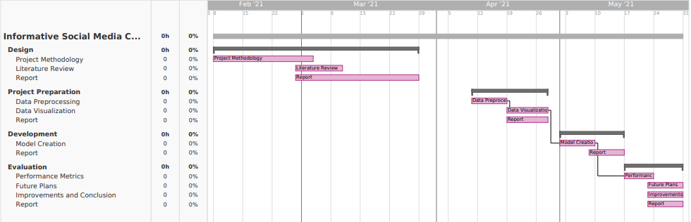

Figure 1.1: Gantt chart

**CHAPTER 2**

1. **Literature Review**

A strong Literature Review (LR) provides validity to the integrity of the research performed. The studying of existing work done by researchers in the same domain refers to as LR. The following papers have been selected and summarized for this research’s LR.

SNSs are a illustration of a virtual network in which users are recommended to attach, communicate and engage with other users in the community. Users of SNSs can have interaction with others with the aid of posting private statistics approximately themselves, sharing data and information, uploading motion pictures and photos, and/or having on the spot and actual-time conversations with others in the identical network via the use of the chat functionality (Shin, 2010). According to Boyd and Ellison (2007), SNSs are defined as net-primarily based services and programs that allow customers to create a public, semi-public, or non-public profile within a bounded device. The users have the potential to create a listing of online friends that contains different users in the equal network with whom they percentage commonplace interests or connections. Each SNS has a one-of-a-kind cause; subsequently, the nature and nomenclature can range depending at the website (Boyd & Ellison, 2007). The area of expertise of SNSs revolves across the fact that they provide the consumer the liberty of no longer best communicating in a network with new human beings, but additionally stepping into touch with humans from their offline social community, the usage of the Internet.

SNSs have evolved through the years and have gone through many levels of improvement to attain their modern-day country (Hendricks, 2013). According to the above definitions of SNSs, the primary recognizable shape of SNSs that endorsed users to encompass non-public information for the cause of social networking emerged in 1997 with a site known as Six Degrees (Boyd & Ellison, 2007). It allowed users to open personal debts and create a list of buddies. Six Degrees attracted over one million subscribers at its top (Chapman, 2009). However, although Six Degrees managed to turn out to be famous and gain a huge wide variety of subscribers, the website become now not capable of keep its popularity (Boyd & Ellison, 2007). In 2001, SixDegrees.Com changed into shutdown. According to the founding father of Six Degrees, the failure of his web page become due to the fact that Six Degrees become ahead of its time: at that point, now not many human beings had buddies who were on-line and the idea of being on line-buddies with strangers had now not but gained standard reputation (Prall, 2010).

Although Six Degrees was close down, the concept of creating virtual social networks inspired other builders (Prall, 2010). In the early 2000s, greater human beings commenced to have Internet get right of entry to; subsequently, the target audience become a whole lot broader than it was. This helped the fulfillment and expanded the popularity of SNSs including Friendster, which has attracted extra than 90 million customers. It delivered the potential for customers to find buddies and then buddies-of-friends, and for this reason extend their networks and proportion greater information with others.

Compared to other SNSs profiles including Facebook, Twitter profiles comprise fewer statistics classes. The user profile carries their call, header photograph (elective), profile photo, a one hundred sixty-person bio (optional), place (elective), link to their internet site (non-obligatory), birthday (non-compulsory), following and followers, and the user’s tweets, that could consist of motion pictures and photographs. Figure 2.1 displays an example of a Twitter profile. The consciousness of Twitter isn't the precise facts about the user, it is the tweets themselves. According to Humphreys, Gill, and Krishnamurthy (2011), tweets not often incorporate in my view identifiable facts which includes smartphone numbers, electronic mail or home addresses. However, they do contain statistics about the sports the person is engaged with in their non-digital international. Leaking sensitive statistics thru tweets could have an effect at the user’s offline existence. For example, tweeting approximately going away on a vacation makes the user vulnerable to theft. As for safety breaches, Twitter has had its truthful proportion. In 2013, Twitter announced that more than 250,000 money owed were hacked (Jones, 2013). In a complicated operation, an anonymous attacker turned into capable of obtain greater than 250,000 bills’ usernames, emails, and passwords. The assault affected extra than 1 / 4 of a million Twitter users at that time (Jones, 2013).

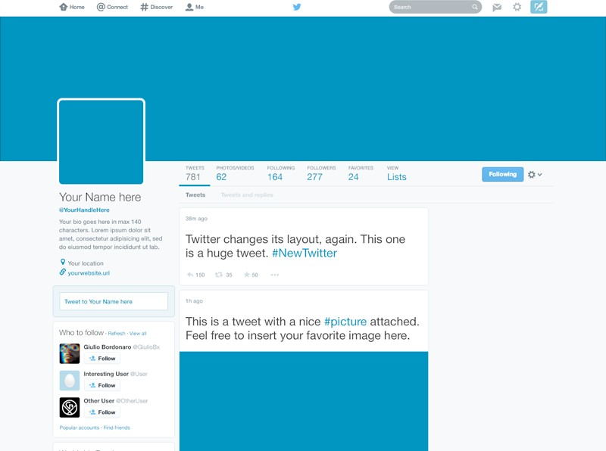

Figure 2. 1: An example of a Twitter profile

Twitter has two separate companies that collect customers’ facts. If the person is based within the US, an American business enterprise, Twitter Inc., collects the consumer information. However if the consumer is anywhere else inside the global, an Irish business enterprise called Twitter International Company collects the facts.

The sizable unfold of SNSs started to occur at the begin of 2003, to begin with while Myspace become launched, which became the most popular SNS within the global at that time (Boyd & Ellison, 2007). Myspace differentiated itself from different competition by way of giving users the liberty to customise the look of their profiles. In 2004, Facebook was launched initially as a Harvard-handiest social community and became the most famous SNS in 2008, overtaking Myspace. As of the second area of 2015, Facebook had 1.Forty nine billion monthly lively users (Statista, 2016). Facebook manages to preserve its fulfillment through continuously enhancing the website online and through adding new capabilities (Hendricks, 2013). At the prevailing time, hundreds of SNSs have emerged, every designed to serve a special target market or have a distinctive fashion that distinguishes it from other SNSs. Figure 2.2 illustrates the tremendous increase of SNSs from 2006 to 2012.

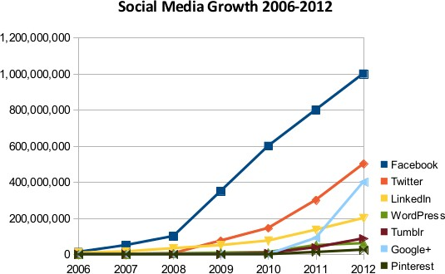

Figure 2.2: Growth of Online Social Networks, 2006-2012. (Source: White, 2013)

Pöyry, Parvinen and Malmivaara (2013) diagram two significant sorts of local area participation dependant on individuals' conduct. The main kind is designated "calm enrollment" and is described by individuals who routinely read others' posts yet rarely post their own assessments, while "open participation" incorporates those, who connect with the local area and their methodology is more dynamic. The investigation additionally depicts how online networks work through the creation and utilization of substance by their individuals. The individuals devour the substance created by others and consequently they gain and move enlightening and social worth. The individuals burn-through the substance through understanding posts, watching recordings or survey pictures posted by others. They are agents of non-intuitive local area conduct, while delivering content falls into the class of intelligent local area utilization conduct. The substance made by clients is a significant piece of the online media wonder. The individuals can add to the local area by making content, for example posting remarks on others' posts, presenting questions related on the local area subject just as by sharing item surveys and encounters.

The specific musical classes that people use as well as the unique classifications that they make are regularly subjective from the basic terms statistics-pushed perspective, and occasionally even irrational. Since most automated category applications require simulating the subjective and probably irrational class judgments that human beings might also make, it is consequently useful to benefit as an awful lot of expertise as viable about the mechanisms utilized by humans to make classifications.

Choy et al., (2018) Machine learning is a process of data discipline which gives skill to computers for learning deprived of being encoded with obvious rules. The design of procedures that can absorb and make accurate and relevant guesses are enabled by Machine learning. Machine learning is taking benefit of bigger exposure to bulky and novel data sets and has the capability to progress and acquire with experiences, instead of rule based algorithms. Fresh developments within machine learning provide potential in many fields and applications, with computed tomography. Machine learning is a course of techniques and area of research which is allowing computers to understand like hominids and making them able to outline or organize configurations. Technologies may be more reliable to further analyze data and snippet features from data that may be humans are not adequate to do. It is known that there are types of machine learning, and these types work with multiple techniques to solve numerous scientific problems. Types of machine learning are named supervised machine learning, semi-supervised machine learning, unsupervised machine learning and reinforcement learning.

Kushwaha et al., (2020) Nowadays, machine learning is becoming an innovative area of research with its application for analysis and prediction purposes. Machine learning is an approach of analyzing data for updating computers. Appropriate selection of actions are must for measuring the accuracy of the system. Machine learning techniques helps to understand and recognize the situation of risk. Machine learning is also playing an important role for development of appropriate cure to control this music classification.

Lötsch et al., (2018) Supervised machine learning means when algorithms are trained to learn which is the accurate assignment from the following parameters for an accurate decision from scientific and storages data, its success is supervised as the information about the accurate detection is existing. Then, the expert algorithm will certainly complete the accurate assignment.

Halgamuge, (2020) Classification algorithm are mostly used by practical applications for prediction and forecasting purposes. Supervised ML proceeds a well-known set of input variables, the known comebacks to the statistics or output variable, and a process that learns the mapping task or trains a model after the input to the output variables. All algorithms and labelled data is used to understand the process of predicting output from the given data.

Muhammad et al., (2020) Years before, ML has resolved numerous complicated and tough real-world issues in the application regions like marketing, business applications and retails applications, natural language processing, health care, autonomous vehicle system, intellectual robots, image processing software and gaming among others. ML techniques had been used for the estimate and decision of numerous. Supervised ML programs are classically based on the trial and error method which is exactly reverse to conventional programs that follow the programming order based on if or else decision.

Hyde et al., (2019) A Support Vector Machine is a process for supervised machine learning that turns an optimal hyper plane in a dimensional space to accurately classify the expected result by the independent variables in the dataset. A Support Vector Machine is an extreme boundary classifier that means it exploits the separation among specific classes of data efficiently in a high dimensional area. SVMs are exclusively useful when the limit between sets is non-linear as points can be definitely transformed to a space in which the limit is linear. For this feature, SVMs are mostly used in classification issues in which the distinction between groups is non-linear.

The fast development in IT over the most recent twenty years has prompted development in the measure of data accessible on the World Wide Web. Another style for trading and sharing data is web-based media. Online media alludes to the methods for communication among individuals wherein they make, offer, and trade data and thoughts in virtual networks and organizations. In today's era, social media users have crossed billions or even trillions in numbers, this means that every single user is creating a bulk amount of data from its account (Badieh Habib Morgan and van Keulen, 2014).

Online media has gotten one of the significant methods for correspondence and substance creation. Thus, modern frameworks that can deal with rich client-created content from the web-based media stage have a few genuine applications. Besides, because of the substance style, size, and heterogeneity of data (e.g., text, emoji’s, hashtags, and so on) accessible via web-based media, novel NLP procedures and frameworks that are planned explicitly for such substance and can conceivably incorporate or take in data from various sources are profoundly valuable and appropriate (Bhargava et al., 2017).

Hareesh Bahuleyan (2018) utilized the machine learning procedures to classifications music consequently through giving labels to the tunes blessing in the client's library. It investigates each Neural Organization and ordinary methodology of utilizing machine learning calculations and to achieve their aim. The main strategy utilizes Convolutional Neural Organization that is gifted offer up to stop the utilization of the highlights of Spectrograms (pics) of the sound sign. The 2d method utilizes various machine learning calculations like Strategic Relapse, Irregular forest, etc, where it utilizes hand-tailored capacities from time region and recurrence area of the sound sign. The physically extricated capacities like Mel-Recurrence Cepstral Coefficients (MFCC), Chroma Highlights, Phantom Centroid, and so forth are utilized to arrange the music into its kinds the utilization of ML calculations like Strategic Relapse, Arbitrary Woodland, Angle Boosting (XGB), and Support Vector Machines (SVM). By looking at the two techniques in a steady progression they arrived at a resolution that VGG-sixteen CNN rendition gave most elevated precision. By building a gathering classifier of VGG-16 CNN and XGB the enhanced adaptation with zero.894 exactness was accomplished.

Tzanetakis G. Et al., (2002) investigated the Melodic kind grouping of sound cautions, they've particularly investigated how the robotized sort of sound signals directly into a chain of command of melodic types is to be done. They acknowledge as obvious that those track classifications are express marks that are made by utilizing individuals just to sort segments of tune. They are arranged through some of the basic qualities. These attributes are typically identified with the contraptions that are utilized, the musical frameworks, and now and again the consonant track content. Type progressive systems are normally used to structure the huge track assortments which are accessible on the web. They have proposed three-element units: the timbre surface, the cadenced substance material, and the pitch content material. The examination of proposed capacities to analyze the general exhibition and the overall importance got done via training the factual example ubiquity classifiers with the guide of using some genuine worldwide sound assortments. Here, in this paper, every entire archive and the real-time body-fundamentally based class plans are characterized. Utilizing the proposed work units, this model can arrange practically 61% of ten tune types effectually.

Lu L. Et al., (2002) provided their view of division and classification of sound substance examination. Here a sound move is fragmented with regards to a sound kind or speaker character. Their strategy is to assemble a tough form that can be characterizing and sectioning the given sound sign into discourse, music, environmental factors sound, and quietness. This class is prepared in chief advances, which has made it reasonable for different bundles as pleasantly. The initial step is discourse and non-discourse segregation. Here, a particular arrangement of rules which depends on KNN (K-closest neighbor) and direct unearthly matches vector quantization (LSP-VQ) is been advanced. The subsequent advance is to separate the non-discourse class into music, natural sounds, and quiet with a standard-based thoroughly class technique. Here they've utilized not many uncommon and new capacities comprising of commotion body proportion, band periodicity which is conveyed, yet referenced in the component. They have moreover covered and progressed a speaker division calculation. This is solo. It utilizes a novel plan dependent on semi - GMM and LSP relationship examination. With no earlier comprehension of something, the model can help the open-set speaker, online speaker displaying, and the constant division.

Comparable to fashion, web-primarily based media is any other outlet to articulate one's thoughts. Be that as it could, this method for articulation takes place inside the net. Numerous fundamental strings join the 2 together. For example, the intellectual attitude to introduce oneself with a selected intention in thoughts exists inside the two retailers. individuals get dressed in a selected technique to introduce themselves to the world around there, almost equivalent to the manner wherein customers might also mastermind their Fb page, Twitter record, or Instagram. Furthermore, the craving to healthy in and be incorporated gives itself through design and internet-based total media. Customers of fashion need to be a chunk of the maximum latest sample and get awards from friends, similar as customers of internet-primarily based media want their "partners" or "adherents" to like and comment on their posts. At remaining, speaking to most of the people is also something the 2 retailers preserve in like manner. These days, there are extra than 1 billion clients of web-based media and minority holes are essentially non-existent. Shockingly, no longer utilizing online media now frequently compares to a beneficiary of elitism, no longer the failure to get to it, as before."Stylish human beings find out it too standard and others find out their protection arrangements irksome. All in all, not utilizing net-based media is probably a result of more education, no longer an absence of getting entry to" (Ferenstein, 2018). Figure 1.3 showing the credibility of the product in different forms or levels.

Deshpande & Thakare reported that to gain suitable knowledge from logically related datasets, scientists have discovered a new domain that is known as data mining i.e. extraction of unknown and useful patterns, information from data. But data mining techniques cannot be helpful always to mine data sets. Big Data is a term that is used to identify larger datasets i.e. larger in size and complexity. These datasets are difficult to mine because they can't get stored, manage, and analyze easily with data mining software or previous tools and technologies. The reason is Big Data sets are heterogeneous in nature i.e. structured or unstructured and extracting useful information from these larger sets or data streams were not possible due to its variety, velocity, and volume [5].

Analyzing abundant data comes under Big Data analytics, which is the procedure of smearing progressive analytics and visualization tools and techniques to determine unknown patterns, correlations that help in authentic decision-making sense. Big Data analytics is a multi-stage process that involves data attainment and recording, information abstraction, cleaning, integration, aggregation and representation, processing query, modeling data, and explanation. Every stage of analysis comprises of various other processing tasks so there come many issues and challenges in mining larger datasets. These issues and challenges majorly include [6].

Heterogeneity and Incompleteness: As Big Data normally deals with structured and unstructured data, this creates a great challenge to mine such huge data. In complicated heterogeneous data (data in multiple formats), data sets can have multiple business rules and patterns implications by concern organizations. It may have no particular format like it may include formats like emails, videos, audio, graphics, x-rays, textual, such formats cannot be stored in structured databases. So there arise issues to transform such datasets into a suitable format. Whereas incomplete datasets or missing values are also a great challenge in analytics.

The business information system has been consumed with the data caused by social networking that raised the requirement to absorb that into their business tasks for superior decision making in the era of big data. Even so, such new streaming of data, generous, unshaped, and variation, bought manages the data warehousing of the structure, and merging of gadgets to their joints have inspired us to perform such research work [16].

We have advanced and narrated a novel proposed system for the big data implementations that can issue recommendations on the behalf of the reaction of the users that creates multimedia satisfaction among more than one user of social networks. The system depends on the 'Usercentered' attitude [17].

Inspecting and removing the understanding of the usergenerated facts has become the matter of attractions between businesses and the investigation team because such facts consist of precious information that could involve viewpoints of consumer, ranking, and guidance of outcomes and solution [18].

Investigation of big data is anticipating research instead of the customary illustrative study of data. Hadoop is been used almost universally as for an investigation of big data in social networks like Google, Gmail, Amazon, Insta gram. The distributed file process is been used by Hadoop for the savings of large proportions of unshaped, present data, and flood at excessive velocity [19].

Subroto and Apriyana (3) described an algorithm model which is used to utilize big data analytics and statistical machine learning to predict the risk of cyber security around social media. Data were collected from early 1999 to 2017 and 25599 cases of cybercrime from Twitter. Prediction of cyber threats through analyzing the software vulnerabilities based on the conversation of social media. In this research mention, some happened cybercrime in 2014 and these crimes are, JPMorgan Chase loss the 250 million us dollars approximately, Sony Pictures Entertainment company lose the 100 million US dollars, Target loss the 1.2 million US dollars and the company name Home Department was the loss the 90 million US dollars.

In the year 2015 Anthem Insurance Company and Ashley Madison lose 80 million and 37 million US dollars respectively. The accuracy of prediction is measured by comparing the given data from social media (Twitter) and. CVE database. Researchers using wreak packages to carry out machine learning Artificial Neural Network and they offer a new vision to understand and predict the risk in cyber security. At the first stage of data analyzing using descriptive analysis like the word cloud and commonality analysis, cluster dendrogram analysis, histogram analysis, and the final analysis is pyramid analysis.

Base on this analysis the common and frequent occurrence word found are Vulnerability, Apache and Exploit in these cyber risk Apache has the highest risk in the cybercrimes, after that use different algorithms support vector machine (SVM), k- nearest neighbor (KNN), decision tree (DT), and artificial neural network (ANN) and comparatively suggest that the ANN have the most accurate result than other algorithms.

K. chan and p. Lippmann (11) present the machine learning algorithm to control the cybercrimes because there are a lot of use computer and the internet in daily life and attract the people to attempt undesired or illegal activities through the computer. Attackers can attack business, the internet of things (IoT) and personal data they can access the private data and may shut down the whole system. Therefore, now a day’s information Security is not a rare topic for discussing. Traditional software of cyber security needs a lot of manual effort for detecting the threats, dig up the characteristics from the risk, and then encrypt through the security software for detecting the threat or virus. This manually and time-consuming process will be handled efficiently through the use of machine learning techniques or algorithms. Many researchers invest and introduce many techniques in machine learning for controlling the cybercrime with more accurately and reliably.

In the beginning, SCADA used in the water control system, transmission, and gas pipeline, and these current days, it also provides efficient solutions in the fields of steel manufacture, telecommunication, manufacturing, chemistry, and experiment, and research facilities. Initially, SCADA has not enough standard introduce for controlling cyber security but after that many standards and directives introduce in SCSDA. National Institute of Standards and Technology (NIST) presents a document of cyber security with the name “System Protection profile - Industrial Control System” this document consists of risks and objects of SCADA in 2004.

National Infrastructure Security Coordination Center issues guide for firewall deployment in SCADA. In 2007, the United States President’s Board of Critical Infrastructure Protection and Energy Department introduce the steps that any government and private organization must improve the security it’s SCADA according to the “booklet 21 steps to Improve Cyber Security of SCADA”. A document present by the Center of Protection and National Infrastructure in 2008 is “Process Control and SCADA Security”.

In 2011, the National Infrastructure of Standard and Technology update the guidelines of how to manage and operate the security control which is released in 2008. Agency of Network and Information Security of the European Union in 2013 enhance the proficiency of SCADA and recommend some related patches. The protocols of SCADA for communication are DNP3, PROFIBUS, ControlNet, Ethernet, IP, MODBUS TCP and Foundation Fieldbus and medium are the satellite, Power line, and radio, or combined it. SCADA system used in Wide Area Network (WAN) that why SCADA covers a large geographical area.

The software which is used in SCADA systems is a real-time database, multi-tasking these functions provides synoptic diagram, text, multi-screen, trend analysis, archiving, report generation, logging many more. There are 10 steps mention in the survey paper about the methodology of SCADA these steps are, i) establish system configuration, (ii) identify quantity model, (iii) identify the security requirement of chief phases, (iv) identify system susceptibilities, (v) categorize the susceptibilities on each device, (vi) estimate the time, (vii) produce graph and attack trails, (viii) evaluation leading attack path, (ix) for enhancing and baseline use 3 and 8 steps, (x) compare the result of system and risk reduction. Definition of Risk According to SCADA “risk is a term of the possibility of an assumed threat source misusing a potential vulnerability and the effect successfully exploitation of the vulnerability”. Modern days SCADA has much ability, sophisticated, modernization, and real-time operation, technological advanced, multi-component architecture, and distribution mechanism for cyber threats.

Peterson and Rognvaldsson (22) described that ANN is another model of machine learning (ML) the development of Artificial Neural Network is inspired by the biological neuron system so simulate the structure and base of functionally like a human brain. As per the name of Artificial Neural Network is a combination of three different words first is Artificial which is defined as it as a presenting of real objector some time called human-made and its function are close to that original object. Second is Neural, neural is an adjective of neurons this was originally taken from the brain of human in our brain there are billions of cells which called neuron and fundamentally work like biological neurons many researcher and developer are used many other alternative words like connection base network, parallel distributed processing network, etc.

Third, the last word is Network, when we used the word network in ANN it’s mean we will use different graph structure (directed graph structure) with labeled weight (values) and use some nodes which are connected and must be applying some computation operation. it’s work like a net it is mean that every neuron/node is connect simulated to the human brain and work to gather so, we say that the Artificial Neural Network is the processing based on an algorithm that can be build complex patterns to predict the problems or provide the solution of that problem.

The similarity between Artificial Neural Network and Biological Brain or Neuron System, to know about the functionality of ANN must be needed to know how BNS work because the idea of ANN techniques is originated from Biological Brain/Neuron. Many problems which we solved on ANN but Also can have solved previous or alternative methods so why we move on ANN, basically ANN is very suitable and efficient for those problem solvers who want to get significant advantages such as cost, easy of debugging/maintenance, accuracy, time and many more.

There is another advantage of ANN to solve the problem by using the lookup table approach. Fundamentally lookup table is used to store all the information for gaining the appropriate result and reference of upcoming events and through lookup table approach to generalize the data and in this generalization, ANN will be trained to provide an appropriate solution to the required problem and ANN train through many inputs according to the problem which we are facing after the training section solution maybe not satisfied if the given query is not matched with training section. Another major advantage of ANN is the memory distributed for large problem or component which is used within the network.

In the 1800s researcher builds an idea that is possible to make a technique or model who works like the human brain like thinking, self-learning, act according to behavior and the ability of many other functions. A simple and basic ANN was developed between the 1960s and 1970s but fall due to lack of accuracy and efficiency, after that in 1986 improve the enhancement of ANN.

The proposed system of this research which is used it consists of four layers: the first one is the sensor layer, the second layer is the object layer, the third phase of layer used the preprocessing layer, and the last layer is used in this proposed system is the application layer. The functionality of these mention layers is describing as sensor layers are also called the data acquisition layer and it consists of n-sensors for the purpose as input variables that are used to sense the environment and send the data to the object layer through a medium which is linked.

After collecting data from sensors it will be saved it in the form of raw material than data will be passed in the layer of preprocessing layer where analyze the data, mitigate the noise, normalize the data and make it in proper form for gaining the maximum accurate result because the collecting data may contain noise, irrelevant or missing information. After data arrange it will be exceeding into the next layer of the application layer. Where the application layer is divided into two main layers: the prediction layer and performance evaluation layer.

The prediction layer is further divided into three layers of the input layer, hidden layer, and output layer and these three layers are perform on the base of Artificial Neural Network (ANN). ANN is a model whose function provides computational results with desire accuracy and efficiency.

There are three major qualities of ANN which make it better from other computational methods and these qualities or advantages are ANN use parallel operation which faster than other computational methods those are used serial operation the reason behind this logic is that the parallelism methods has a high degree of sharing information or i/o signals because of distributed memory.

Second is ANN learn from Data and store this information into the lookup table and third it uses nonlinear processing function to manage the complex nonlinear problems. ANN has very excellent properties such as self-learning, progressively in input to an output arranging, adaptively, and nonlinear problem that’s the reason ANN is mostly used in for universal calculation in numerical standards.

ANN is applied in various applications such as the social media information extraction, medical field, image processing, pattern recognition, speech recognition, radar recognition, air traffic system, power supply system, cybersecurity, and many more.

Bitter et al. (23) describe the importance of security not only in the pure IT department but also in those areas involved with the internet or computer. They defined that when we talk or concern with cyber security, we must accomplish three major qualities and these qualities are availability, confidentially and integrity and these qualities are satisfying with regulation, policies, and authorities. ANN successfully applied on a broad range of problem such as medical areas (heart, HIV aids, hepatitis, diabetes, etc.), finance (credit card, transactions, etc.), engineering (machine monitoring, robot, automobiles, etc.), Science (biology, chemistry, physics, nuclear physics, etc.).

Abiodun et al. (24) describe the survey paper about the application of ANN which is used in real-world scenarios. These coming days ANN very popular and useful model for a different discipline like prediction, clustering, classification, pattern recognition, etc. This review study author furthermore presents the ANN application challenges, contribution, compare performance, evaluation methods.

Lekand J.F. Gue´gan (25) described that ANN is a powerful tool for prediction or solution of any problems and it has a very strong function and different types of algorithms or models also it shows universal and flexibility for any data. Prediction of modeling ANN is having a well-known approach use name ‘black box’ and this word black box means that all characters have an unknown situation, so these characters are identifying through training of ANN.

Jack V (26) described that Artificial Neural Network has a lot of advantages including requiring less formal statistical training to ANN for predict or finding the solution of a particular problem, ANN has the ability to point out all possible relation between predictor variables, there is a variety of algorithm and model are used in it for problem-solving and these algorithms and software/model and packages are easily available in the simple range, user-friendly, mostly graphical user interface (GUI), detect the non-linear relationship between dependent and independent variables, multiple algorithms are used to raining of an ANN, no need to know deep knowledge for developing/training of ANN just know about the basic structure of ANN model and data or parameters that can be adjusted with the model.

For improving efficiency in this paper use cost analyzed and multiple models approach through this methodology proposed low cost and high efficiency they also present a distributed architecture with real-time for evaluating cost-sensitive. The third issue which mentions in this paper was usability because a IDSs which is based on data mining is more complex compare to a traditional system and this issue improving by an adaptive learning algorithm to develop the model construction and increasing the update for this purpose used unsupervised anomaly detection algorithm. In this research paper, they discuss and present an architecture which is consisting of detectors, model generation, sensors, data warehouse, and by implementing this architecture improves the efficiency and scalability of the IDSs.

Dartigue et al. (29) describe that how data mining is improving the intrusion detection in the field of cyber security because in present days the internet is more open and everyone is hanging on the internet for saving the information that’s why the security risks have been increased in the area of cybercrimes. In 2005 the pentagon publishes a paper which mentions that over 79000 effort to intrusion and 1300 are success one so watching all these circumferences need to introduce new intrusion detection systems (IDSs) because older techniques are not enough for controlling the attack on cyber life. In this paper, the authors present the join of classifiers use with feature selection and multi boosting techniques based on data mining for the purpose of intrusion detection.

With the help of the feature selection model is more enhances the ability to intrusion detect for each type of attack. during training data in this model applies a new approach of ensemble which accept the input and decide that which class is better on given input but the bias may be alleviated of concern binary classifier in other binary classifier conclusions for this case use multi boosting model increase the improvement of intrusion detect by reducing the variance and bias.494021 data are used for testing and training the model and there are 41 various qualitative and quantitative features extracted for each record but the original data was 744 megabytes (MB) and this data consists of 4,900,000 records.

For this examination, the creators take information from four unique spaces for the area investigation for example Web-based media, biomedical, synthetic and unstructured information. The justification picking these areas was their brutal improvement rate supportive results showing up every day from them.

To isolate organized information from unstructured and semi-organized information is the thing that IE does. There are two significant assignments in IE. Both have mainstream moves toward that are generally utilized for research purposes.

Name Entity Recognition (NER)

NER endeavors to find and arrange named substances from the substance into predefined classes. The mainstream approaches utilized in this are as per the following:

Example Based Method (PBM)

This is the most punctual of strategies for IE. Conventional IE strategies use design acknowledgment and word references to remove information from unlabeled information. PBM for IE isn't not difficult to carry out for online media. The explanation for this is that the information isn't standardized. Continuous IE frameworks are hard to make with PBM in the clinical space moreover. This is because of the danger of getting erroneous outcomes in regards to patient determination from the reports and patient information. PBM isn't utilized in the synthetic space too. This is because of the extremely huge information word reference of synthetic mixtures, iotas and atom names that isn't feasible for PBM to deal with. Rule-based techniques are utilized for information identified with the substance area.

Rule-based Method (RBM)

This strategy is firmly identified with Decision Trees. The lone contrast is that DTs don't make a severe progressive division of the preparation information for example covering is permitted which makes the preparation more powerful.

The RBM has been utilized for protein and quality element acknowledgment in the biomedical area. Utilizing RBM makes it hard to concentrate and name substances from unstructured information. However, utilizing word references for example seeds to launch that acknowledgment cycle has worked in a couple of explores. RBM has additionally been utilized for question extraction and discovery from twitter microblogs. In the synthetic area, RBM has been utilized to distinguish substances just as standardize the content while recognizing the limits of the sentences in the content.

Measurable Learning Method (SLM)

SML alludes to the assignment of a likelihood circulation of the assessment that catches the measurable principles of regular language preparing. There are three mainstream approaches utilized in this strategy:

Greatest Likelihood Estimation Method (MLEM)

NER is simple in English since the language is not difficult to appreciate, the standards are clear and the sentences are made by consolidating words together. In any case, a language like Chinese is troublesome since sentence making in Chinese is something contrary to English. MLEM has been utilized to effectively sort out the unstructured Chinese information. MELM has been utilized for ascertaining probabilities in the biomedical area. MLEM additionally helps increment the productivity if MLEM is engaged with the calculation preparing measure.

MLEM can't be utilized for any work in the synthetic space for a similar explanation PBM can't be utilized. The intricacy of the information for example the conditions, recipes is an excessive lot. MLEM has been utilized for element acknowledgment from online media combined with the label n-gram approach.

Hidden Markov Model (HMM)

HMM has been utilized effectively for NER in dialects like Kannada that give complex unstructured information. HMM was joined with the RBM approach for amazing outcomes. Regardless of the way that there exists a tremendous number of biomedical information on the web, HMM was utilized for NER, with a word equivalence based smoothing. The tests show that the word similitude-based smoothing can upgrade the execution by using tremendous unlabeled data.

Online media related datasets struggle working with HMM because of unpredictable sentence organizing, message language and sporadic capitalization. Yet, results have been accomplished in this area by joining HMM with n-gram for a half breed approach N-gram Language Markov Model (NLMM). A genuinely necessary accomplishment in the compound area in regards to extraction of data has been accomplished by HMM. Connecting compound names of components with their images for example the image for lead is PB.

Support Vector Machines (SVM)

SVMs utilize the force of straight variable based math to make limits between various information classes. The force of detachment is key in the outcomes from SVM. This methodology has been effectively used to extricate singular data from the Swedish language like names, organization area and time. SVM has likewise been used for biomedical information NER. The issue in managing web-based media information is that ordinary NER techniques are made to manage formal content appropriately composed writing accessible in papers, and so on however, online media doesn't have this. In addition, there is information in numerous dialects via online media. Be that as it may, SVM has outflanked HMM in such manner. The lone detriment of SVM is that it is moderate.

Relation Extraction

The second assignment in IE, this concentrates the connection among substances and the substance of the information. The accompanying famous methodologies are utilized for this:

Administered Learning Models

The objective here is to recognize designs and gain from a named dataset for forecast. The accompanying methodologies are famous in this segment:

Feature Based Classification Method (FBCM)

The contrast among RBM and FBCM is the extent of information used. While RBM utilizes an engaged, more modest extent of information for clarifying the relations among substances and the specific situation, FBCM utilizes a wide scope of relevant information. Customary FBCM are ill suited for information of web-based media to the extent abusing the additional information in connected data. In this way, to make the one-of-a-kind relations that can be separated from connected information is known as connection extraction. This is utilized for online media.

The issue with FBCM is that occasionally information with unequivocal element vectors can't be addressed without any problem. In these cases, the extraction of qualities is an exceptionally intricate assignment and prompts vectors of extremely high measurement, which thus prompts issues of estimation. Part based strategies endeavor to tackle this issue certainly depend on scalar vector items are determined at extremely high Dimensional spaces with no sort of vector should be unequivocal

Kernel Learning Method (KLM)

KLM gives an amazing and steady system for every one of these orders, rousing calculations that can follow up on broad kinds of information like content and for the overall sorts of connections e.g., arrangement, connection extraction, and example acknowledgment.

Convolutional Neural Networks (CNN)

Connection extraction structures have made expansive usage of parts made by investigation of information. The answer for the issue of connection extraction can be gotten by the utilization of CNN.

Semi-supervised Learning Methods

Calculations are prepared on a dataset containing unlabeled and marked information. This cycle is anyway costly regarding preparing, time and information required. Utilizing approaches that don't need a lot of information is fundamental.

Multi-Instance Learning (MIL)

The preparation dataset for this methodology comes in areas, and each part is loaded up with numerous cases. MIL calculations discover events in the areas. At that point those events are utilized for preparing. The events are portrayed by the segments to which they have a place.

Bootstrapping Method (BM)

BM which is used to remove connections have acquired extensive consideration lately. These methodologies are built with a central suspicion that in the event that you a few words that relate with a specific goal in mind, phrases containing these words, these sorts of words probably make connections to communicate. Along these lines, the sentences containing the word pair are utilized as preparing information for the connection extraction.

Graph Based Method (GBM)

BM are notable for the extraction of connections, principally since they require only a bit of measure of human evaluation. Charts can address complex connections among classes and cases. A vague occasion; For instance, Usman Khawaja may be among the class of pilots and players. Today online media like Facebook beats the web. Scientists are dealing with the investigation of web-based media for connection extraction from remarks, tweets just as posts. In online media, the proposed execution of this strategy is a unique outspread diagram to adapt to the constraints of past representation procedures. The capacity to exactly get a handle on both semantic and syntactic designs in biomedical information ends up being continuously fundamental and permit exceptional comprehension of logical papers and clinical information.

Unsupervised Learning Methods

In unaided realizing there is no such managed or organized information and we simply have input data. The goal is to find predictabilities at the event.

Clustering Method (CM)

Due to the huge number of connections between substances, it very well might be exorbitant to cover an adequately huge measure of preparing information to successfully stamp each sort of relationship in each new space of interest. CM can be viewed as significant learning without administering the issue; actually, like any such issue, attempt to discover a construction in an assortment of unlabeled information just as it is vital unaided method. Substances are assembled by their clear-cut data. To utilize web-based media networks for the Semantic Web, a couple of surveys have investigated programmed connection extraction of web-based media.

Open Information Extraction (Open IE)

IE frameworks attempt to extricate the semantics of text in characteristic language connections; however, most frameworks utilize directed explicit instances of the relationship to learn and in this manner fractional by the convenience of preparing information. Open IE structure, relies completely upon the data substance and its etymological characteristics. Even more especially make guides to get these characteristics of substance and a short time later separate relation.

Wrapper Induction Method (WIM)

This method is an extraction procedure that involves a course of action of extraction rules and program code needed to execute these principles. WIM gain proficiency with the covering naturally. Given a grouping of preparing information, the enlistment calculation sorts out some way to remove a covering objective information. Results The shortcomings of each approach have been summed up in the accompanying tables from the examination paper.

**CHAPTER 3**

1. **Project Design and Methodology**

Research Methodology is a method or computational techniques which are used for different purpose like process (observation, simulation, derived, experiment), data gathering, and analysis about a specific topic or problem. Data was collected from kaggle the social experiment was on Twitter social network. Due to the uniqueness and popularity of chosen network and the fact that requests and presents different kinds of information, it was decided that data would be collected, rather than generalizing the survey questions and the social experiment on all social network as a single entity.

In Twitter, for instance, the link for the survey was tweeted with trending hash-tags in order to ensure it had wide exposure. In the post, there was a brief description of the survey in order to encourage users to take part in it. For the social experiment, users were selected randomly from their participation in public pages such as newspapers or public figures’ pages by either liking a post or commenting on a post.

In this research paper, the creators propose a structure for Information Extraction (IE) from unstructured client produced substance via online media. The structure proposes answers for defeat the IE challenges in this space like the short setting, the loud scanty substance and the questionable substance. To conquer the difficulties confronting IE from web-based media, State-Of-The-Art approaches should be adjusted to suit the idea of web-based media posts. The key segments and parts of the proposed system are noisy content sifting, named element extraction, named substance disambiguation, criticism circles, and vulnerability taking care of.

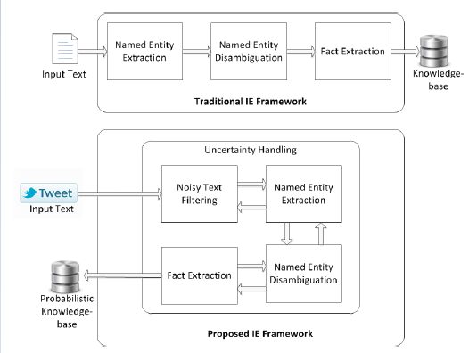

Figure 3.1: Proposed Methodology

The dataset that is finalized for this project is the informative tweets dataset. The dataset is pre-split into the training dataset with 6936 data instances and test dataset with 2000 data instances. The features in the dataset are as follows:

* Id: tweet id for dataset management
* Text: the body content from the tweet
* Label: binary feature with two output classes i.e., Informative and Uninformative.

To explore a probabilistic approach to IE from twitter is the aim of this project. To that extent, the Naïve Bayes algorithm will be implemented for this research experiment. The Naïve Bayes algorithm is based on the theorem that is stated as follows:

Let,

A, B be two events under observation. Assuming that event B has already occurred. This theorem helps calculate the probability of the occurrence of event A given that event B has already occurred. It is calculated in the following way:

$$P\left(A | B\right)=\frac{P\left(B | A\right).P(A)}{P(B)}$$

The methodology for the working of this project takes inspiration from spam detection. Spam detection also uses Naïve Bayes theorem to detect spam mail. This project will use the same methodology for the identification of Informative tweets from twitter.

The Naïve Bayes theorem requires a set of keywords to jumpstart and train the process of identification. Those keywords will be provided from **Description** feature in the dataset. This feature will be passed on to the TF-IDF algorithm. TF-IDF stands for “Term Frequency — Inverse Document Frequency”. This is a technique to quantify a word in documents, we generally compute a weight to each word which signifies the importance of the word in the document and corpus.

TF-IDF is calculated as follows, let **t** be the text in the document d, then:

Term Frequency: the number of times a word has occurred in a document.

$$tf\left(t,d\right)=\frac{count(t,d)}{number of words in d}$$

Document Frequency: The number of times t has occurred in the dataset:

$$df\left(t\right)=occurence of t in dataset$$

Inverse document frequency: This measures the informative capacity of t.

$idf\left(t\right)=log⁡(\frac{N}{df+1})$; where log is used to compensate for large datasets

TF-IDF is then calculated using the following:

$$tf-idf\left(t,d\right)=tf\left(t,d\right)*log⁡(\frac{N}{df+1})$$

The results of the TF-IDF will be provided to Naïve Bayes model. Given that a keyword *t $∈$* output of the TF-IDF, Naïve Bayes will return the probability of a tweet being informative in nature. The model will be tested on the **Text** feature of the dataset. The dataset requires annotation regarding the nature of the tweets but this would be decided with further research on this approach. The reason behind the annotation is to employ performance metrics to measure the accuracy of the approach.

**CHAPTER 4**

1. **Results and Discussion**

The processes that provide assistance in the completion of the coding and experimentation section of the research. The coding/experimentation section is divided into three subsections that handle the following:

* Data Pre-processing
* Natural Language Processing
* Machine Learning Model

Data Pre-processing

This section deals with the import of the dataset, studying it and adjusting it i.e. getting rid of the anomalies in it and preparing it for the training and experimentation.

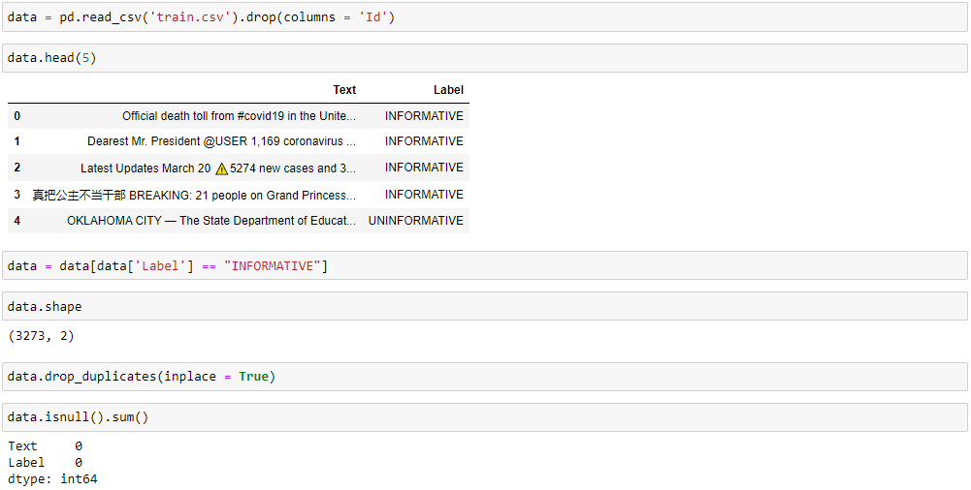

The above code does the data pre-processing section of the code. The code above imports the data into the code for usage using *pandas.* A sample of 5 instances from the dataset is displayed to understand the features in the dataset. The code also provides the shape of the dataset which is just the number of rows and columns in the dataset. The code then targets the duplicate and null instances in the dataset and removes them. The dataset has two labels i.e., “INFORMATIVE” and “UNINFORMATIVE”.

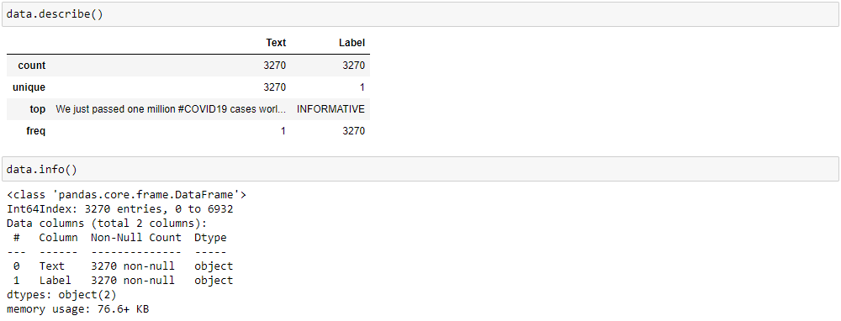

The dataset is also analyzed for its metadata i.e. data about its features like their data types and number of non-null features. The features are also analyzed statistically using “*data. Describe ()”.* The dataset is then divided into training and testing dataset in the 70:30 ratio for cross validation as follows:



This completes the data pre-processing section.

Since the paradigm followed for the code in this research is NLP based, the features have to be extracted from the dataset that satisfy the working of the NLP paradigm. The features here mean the keywords that will be extracted from the dataset to train the Machine Learning algorithm.

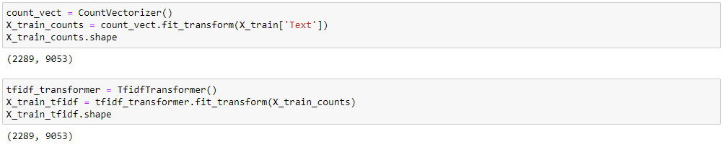

The code above performs the NLP processes for extracting keywords from the dataset to create a bag of words that will train the Machine Learning algorithm. The *CountVectorizer ( )* is used to extract the keywords from the dataset while the *TfIdfTransformer ( )* is used to transform the extracted bag of words into a td-idf representation. This completes the natural language processing section.

The algorithms used in this research are the Bernoulli Naïve Bayes Algorithm, The Support Vector Machine and the Decision Tree since the dataset has binary output and these algorithms specialize in classification. The algorithms are trained on the bag of words extracted above and the tested using the test dataset. The performance is measured using the mean method.

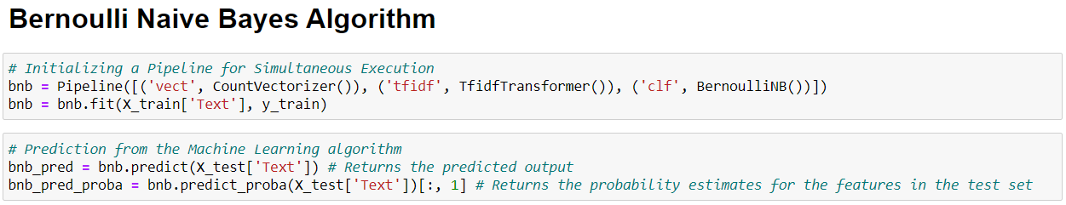

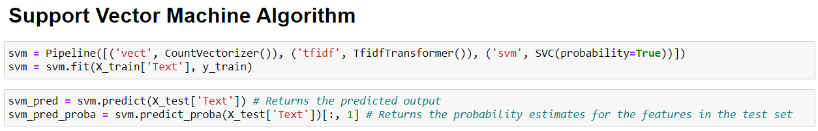

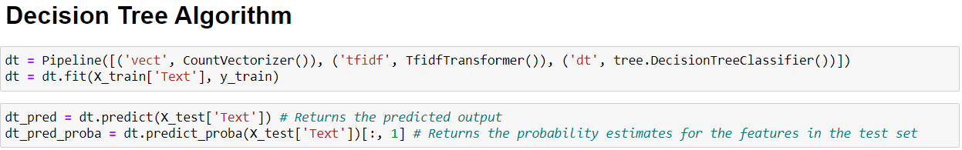

**Performance Metrics**

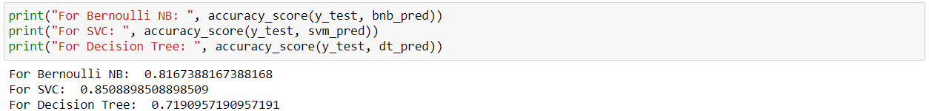

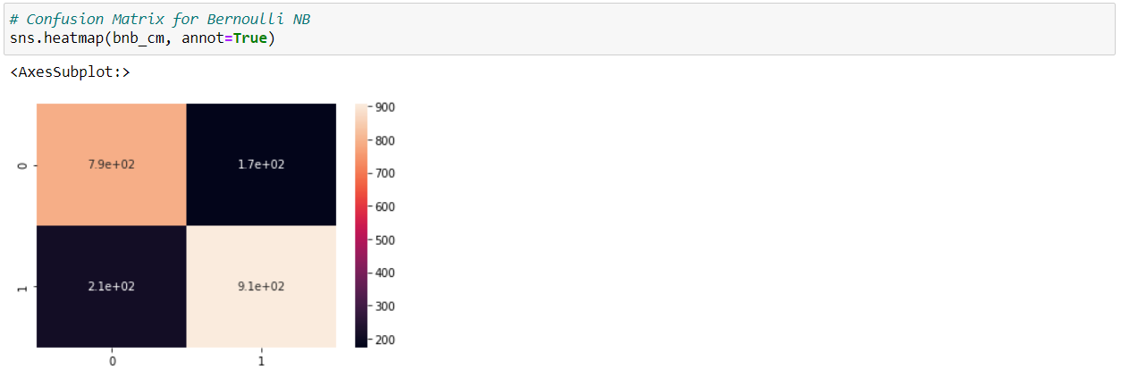

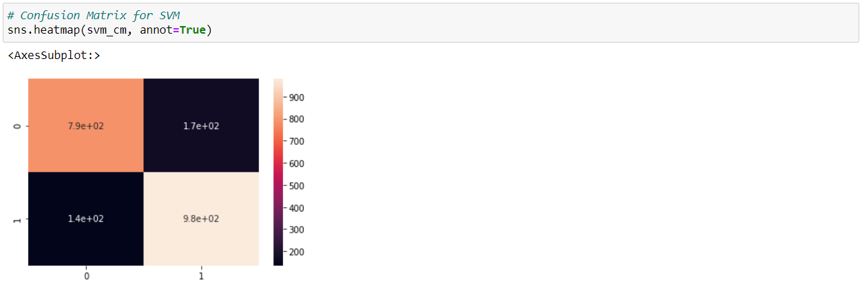

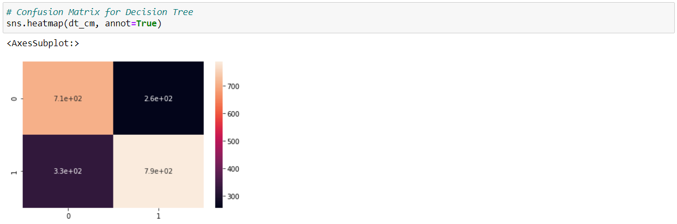

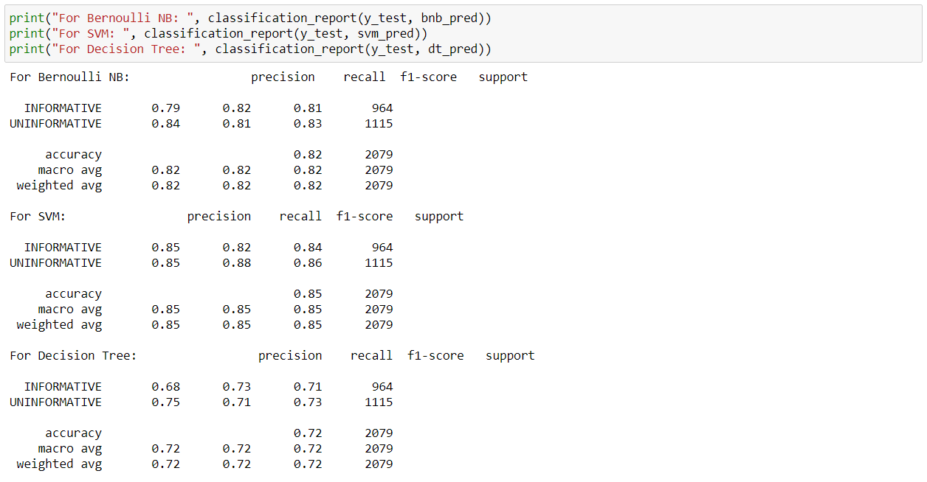

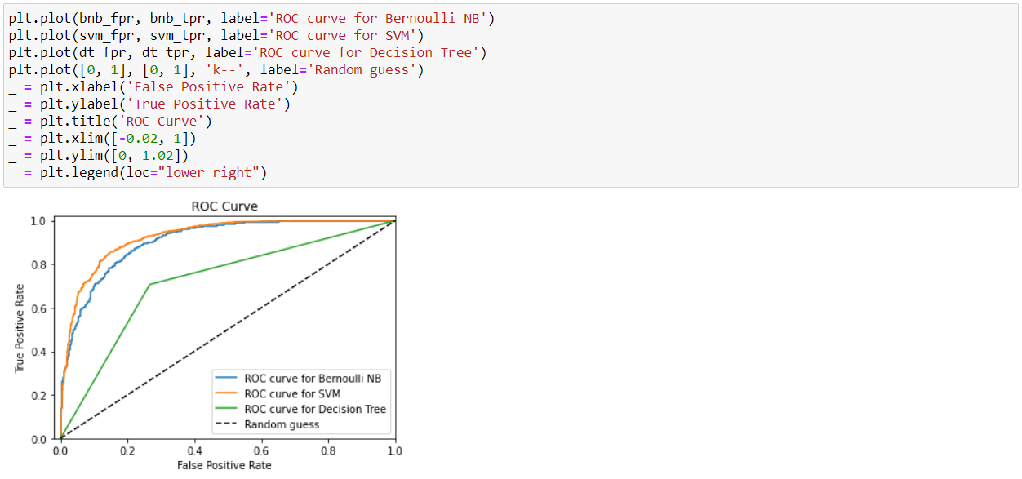

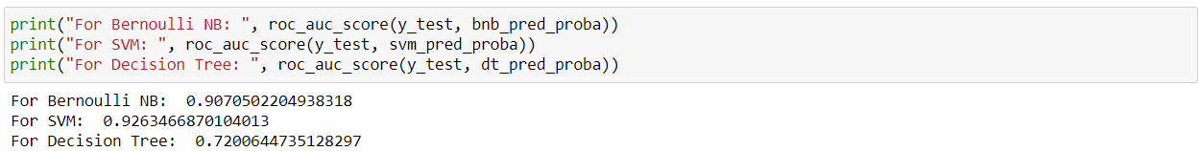

As the results show, out of the three algorithms, SVM performs the best giving 85% accuracy over the Bernoulli NB that gives a close 82% accuracy. The decision tree comes in last with an accuracy of 72%.

**CHAPTER 5**

**Conclusion**

Since social media is so popular, people have been referring more social media for updates on what is happening aroundSocialbackgrou the world. Social networking sites have revolutionized traditional information-sharing methods. They are mostly built on an individual’s offline social circle and they provide users with a wide variety of virtual interaction mechanisms. Due to freedom of usage in social media, it generates a lot of data sifting through which is hard work. Twitter have been mainstays for quite some time now. This research is focused on dealing with this issue by automating the process of finding informative content on social media. The purpose of this research to identify the informative social media content identification from twitter enabled with machine learning in the form of Naïve Bayes Theorem.

**References**

1. Qian, Y., Santus, E., Jin, Z., Guo, J. and Barzilay, R., 2019. GraphIE: A Graph-Based Framework for Information Extraction. Proceedings of the 2019 Conference of the North.
2. Badieh Habib Morgan, M. and van Keulen, M., 2014. Information Extraction for Social Media. Proceedings of the Third Workshop on Semantic Web and Information Extraction.
3. Bhargava, P., Spasojevic, N. and Hu, G., 2017. Lithium NLP: A System for Rich Information Extraction from Noisy User Generated Text on Social Media. Proceedings of the 3rd Workshop on Noisy User-generated Text.
4. Mahboob Alam, T. and Javed Awan, M., 2018. Domain Analysis of Information Extraction Techniques. INTERNATIONAL JOURNAL OF MULTIDISCIPLINARY SCIENCES AND ENGINEERING, 9(6).
5. Michael, A., Armando, F., Rean, G., Anthony, D. J., & Katz, R. (2010). A view of cloud computing. Communications of the ACM.
6. Fan, W., & Gordon, M. D. (2014). The power of social media analytics. Communications of the ACM, 57(6), 74-81.
7. Gantz, J., & Reinsel, D. (2012). The digital universe in 2020: Big data, bigger digital shadows, and the biggest growth in the Far East. IDC iView: IDC Analyze the future, 2007(2012), 1-16.
8. Zeng, D., Chen, H., Lusch, R., & Li, S. H. (2010). Social media analytics and intelligence. IEEE Intelligent Systems, 25(6), 13- 16.
9. Liu, B. (2012). Sentiment analysis and opinion mining. Synthesis lectures on human language technologies, 5(1), 1-167.
10. Liu, B. (2012). Sentiment analysis and opinion mining. Synthesis lectures on human language technologies, 5(1), 1-167.
11. Karun, A. K., & Chitharanjan, K. (2013, April). A review on Hadoop—HDFS infrastructure extensions. In 2013 IEEE conference on information & communication technologies (pp. 132-137). IEEE.
12. Mangold, W. G., & Faulds, D. J. (2009). Social media: The new hybrid element of the promotion mix. Business Horizons, 52(4), 357-365.
13. Chen, C. P., & Zhang, C. Y. (2014). Dataintensive applications, challenges, techniques and technologies: A survey on Big Data. Information sciences, 275, 314-347.
14. Flood, M. D., Jagadish, H. V., & Raschid, L. (2016). Big data challenges and opportunities in financial stability monitoring. Banque de France, Financial Stability Review, 20, 129-42.
15. Kulkarni, A. P., & Khandewal, M. (2014). Survey on Hadoop and Introduction to YARN.
16. Coronel, C., & Morris, S. (2016). Database systems: design, implementation, & management. Cengage Learning.
17. Sowmya, R., & Suneetha, K. R. (2017, January). Data mining with big data. In 2017 11th International Conference on Intelligent Systems and Control (ISCO) (pp. 246-250). IEEE.
18. Basha, S. A. K., Basha, S. M., Vincent, D. R., & Rajput, D. S. (2019). Challenges in Storing and Processing Big Data Using Hadoop and Spark. In Deep Learning and Parallel Computing Environment for Bioengineering Systems (pp. 179-187). Academic Press.
19. Karpagam, N. S., Thrilokesh, G. K., Shanker, J., Harish, K., & Raja, M. (2017, February). Split reading of redundant datasets on data nodes using Hadoop framework. In 2017 International Conference on Algorithms, Methodology, Models and Applications in Emerging Technologies (ICAMMAET) (pp. 1-3). IEEE.
20. Jenhani, F., Gouider, M. S., & Said, L. B. (2019). Streaming Social Media Data Analysis for Events Extraction and Warehousing using Hadoop and Storm: Drug Abuse Case Study. Procedia Computer Science, 159, 1459-1467.
21. Amato, F., Moscato, V., Picariello, A., & Piccialli, F. (2019). SOS: A multimedia recommender System for Online Social networks. Future generation computer systems, 93, 914-923.
22. Chang, Y. C., Ku, C. H., & Chen, C. H. (2019). Social media analytics: Extracting and visualizing Hilton hotel ratings and reviews from TripAdvisor. International Journal of Information Management, 48, 263-279.
23. Suganya, S., & Selvamuthukumaran, S. (2018, March). Hadoop Distributed File System Security-A Review. In 2018 International Conference on Current Trends towards Converging Technologies (ICCTCT) (pp. 1-5). IEEE.
24. Jimenez-Marquez, J. L., Gonzalez-Carrasco, I., Lopez-Cuadrado, J. L., & Ruiz-Mezcua, B. (2019). Towards a big data framework for analyzing social media content. International Journal of Information Management, 44, 1-12.
25. Berman, D. S., Buczak, A. L., Chavis, J. S., & Corbett, C. L. (2019). A survey of deep learning methods for cyber security. *Information*, *10*(4), 122.
26. Zhang, Y., Lee, W., & Huang, Y. A. (2003). Intrusion detection techniques for mobile wireless networks. *Wireless Networks*, *9*(5), 545-556.
27. Subroto, A., & Apriyana, A. (2019). Cyber risk prediction through social media big data analytics and statistical machine learning. *Journal of Big Data*, *6*(1),50.
28. Dlamini, M.T., Eloff, J.H., & Eloff, M.M. (2009). Information security: The moving target *computers & security*, *28*(3-4), 189-198
29. Meso, P., Ding, Y., & Xu, S. (2013). Applying protection motivation theory to information security training for college students. *Journal of Information Privacy and Security*, *9*(1),47-6
30. Craigen, D., Diakun-Thibault, N., & Purse, R. (2014). Defining cybersecurity. *Technology Innovation Management Review*, *4*(10).
31. Posey Garrison, C., & Ncube, M. (2011). A longitudinal analysis of data breaches. *Information Management & Computer Security*, *19*(4),216-230.
32. Gordon, L. A., & Loeb, M. P. (2006). Economic aspects of information security: An emerging field of research. *Information Systems Frontiers*, *8*(5),335-337.
33. Cazacu, M., & Cucu, C. (2019). Using the Activity Theory to Identify the Challenges of Designing E-learning Tools based on Machine Learning for Security Operations Centers. In *The International Scientific Conference eLearning and Software for Education* (Vol. 1, pp. 452-461). " Carol I" National Defense University.
34. Gordon, L. A., Loeb, M. P., Lucyshyn, W., & Zhou, L. (2014). Externalities and the magnitude of cyber security underinvestment by private sector firms: a modification of the Gordon-Loeb model. *Journal of Information Security*, *6*(01), 24.
35. Chan, P. K., & Lippmann, R. P. (2006). Machine learning for computer security. *Journal of Machine Learning Research*, *7*(Dec), 2669-2672.
36. Noor, U., Anwar, Z., Malik, A.W., Khan, S.,&Saleem, S.(2019).A machine learning framework for investigating data breaches based on semantic analysis of adversary’s attack patterns in threat intelligence repositories. *Future Generation Computer Systems*, *95*,467-487
37. Bhuyan, M. H., Bhattacharyya, D. K., & Kalita, J. K. (2013). Network anomaly detection: methods, systems and tools. *Ieee communications surveys & tutorials*, *16*(1), 303-336.
38. Garcia-Teodoro, P., Diaz-Verdejo, J., Maciá-Fernández, G., & Vázquez, E. (2009). Anomaly-based network intrusion detection: Techniques, systems and challenges. *computers & security*, *28*(1-2), 18-28.
39. O’connell, M. E., Arimatsu, L., & Wilmshurst, E. (2012, May). Cyber security and international law. In *International Law Meeting Summary, Chatham House* (pp. 5-7).
40. Jerome, O. U. (2012). *Cybersecurity Law & Regulation*. Wolf Legal.
41. Schjolberg, S. (2008). The history of global harmonization on cybercrime legislation–the road to geneva. *Journal of International Commercial Law and Technology*, *1*(12), 1-19.
42. Hemsley, K., & Fisher, R. (2018, March). A History of cyber incidents and threats involving industrial control systems. In *International Conference on Critical Infrastructure Protection* (pp. 215-242). Springer, Cham.
43. Syed, R., Khaver, A. A., & Yasin, M. (2019). Cyber Security: Where Does Pakistan Stand?.
44. Cherdantseva, Y., Burnap, P., Blyth, A., Eden, P., Jones, K., Soulsby, H., & Stoddart, K. (2016). A review of cyber security risk assessment methods for SCADA systems. *Computers & Security*, *56*, 1-27.
45. Peterson, C., & Rögnvaldsson, T. S. (1991). *An introduction to artificial neural networks* (No. LU-TP-91-23). CERN.
46. Bitter, C., Elizondo, D. A., & Watson, T. (2010, July). Application of artificial neural networks and related techniques to intrusion detection. In *The 2010 International Joint Conference on Neural Networks (IJCNN)* (pp. 1-8). IEEE.
47. Abiodun, O. I., Jantan, A., Omolara, A. E., Dada, K. V., Mohamed, N. A., & Arshad, H. (2018). State-of-the-art in artificial neural network applications: A survey. *Heliyon*, *4*(11), e00938.
48. Lek, S., & Guégan, J. F. (1999). Artificial neural networks as a tool in ecological modeling, an introduction. *Ecological modeling*, *120*(2-3), 65-73.
49. Tu, J. V. (1996). Advantages and disadvantages of using artificial neural networks versus logistic regression for predicting medical outcomes. *Journal of clinical epidemiology*, *49*(11), 1225-1231.
50. Zhang, X. and He, R., 2018. Topic Extraction of Events on social media Using Reinforced Knowledge. Knowledge Science, Engineering and Management, pp.465-476.